

Course Name: Introduction to Software Engineering
Course Code: IS1103-1
Assignment Number: 1
Title: Study of Software Development Life Cycle Models with Reference to Amazon
Student Name: Anna Seric Fernandes
USN / Roll Number: NNM24IS033
Semester: IV
Section: A
Department: Information Science & Engineering
Institution Name: NMAM Institute of Technology
Academic Year: 2025-2026
Instructor Name: Dr. Jason Elroy Martis
Date of Submission: 13-02-2026

ABSTRACT
This report looks at the Software Development Life Cycle (SDLC) of the Amazon Online Shopping Application. Millions of people around the world use this application. The main issue discussed is how to manage various functional and non-functional requirements in a system that continually evolves and must handle high traffic, security, and performance demands. It compares three SDLC models: Waterfall, Incremental Development, and Spiral Model. The comparison focuses on how each model supports requirements management, risk control, cost, and time.
A basic requirements document includes the following key features: product search, ordering, payment, and user account management. It also includes essential quality requirements such as security, reliability, usability, and scalability. The report describes how to verify the requirements, using stakeholder reviews, basic prototyping, and requirement verification, and points out issues such as changing requirements and communication gaps.
The comparison reveals that the Incremental and Spiral models are more suitable for rapidly changing systems such as Amazon because they address risks and changes more effectively than the Waterfall model. According to the study, iterative and risk-management models are the most appropriate for large e-commerce applications.

GITHUB REPOSITORY LINK
GitHub URL:

INTRODUCTION
This assignment examines the Software Development Life Cycle (SDLC) of the Amazon Online Shopping Application. The primary objective of this assignment is to determine how various software development process models, such as the Waterfall Model, Incremental Development Model, and Spiral Model, influence the management of requirements in a large-scale system. This assignment
also entails creating a basic requirement engineering document and determining the approach to be used for the verification of requirements. Through a comparison of the various models, this assignment seeks to determine the most appropriate development model for systems requiring frequent updates, high reliability, and effective risk management.
This problem applies software engineering concepts, but large e-commerce sites such as Amazon rely heavily on deep learning as well. Deep learning techniques enhance product recommendation, search, fraud detection, and our understanding of customer behavior. Deep learning assists in dealing with a lot of customer data and makes the experience better and more personalized.
This topic corresponds to Unit I: Introduction and Requirements Engineering. This topic includes SDLC models, requirements analysis, functional and non-functional requirements, and methods for validating requirements, which are the major topics in this unit.

PROBLEM STATEMENT
This assignment focuses on studying how the large-scale Amazon Online Shopping Application can be developed and managed using different Software Development Life Cycle (SDLC) models. The main task is to analyse and compare the Waterfall, Incremental, and Spiral models. It is important to understand how each model affects requirements management in a complex system. The assignment also includes preparing a simplified requirements document that covers both functional requirements, such as product search, ordering, and payment, and non-functional requirements like security, performance, and reliability. Additionally, the task involves explaining how requirements are validated and the challenges that may arise during this process.

The expected outcome is a clear understanding of which development model works best for a large and continually changing e-commerce platform. The report should show how different models handle risks, changes in requirements, time, and costs. It should also highlight how proper requirements engineering can improve software quality and minimize development issues.
This study assumes the Amazon application is a large, evolving system that serves many users and receives frequent updates. Since we do not have access to Amazon's real internal data, the analysis draws on general knowledge of e-commerce systems and standard software engineering practices. Time and resource limitations are also considered as we simplify the requirements and system scope.

SYSTEM DESCRIPTION
As one of the world's biggest digital marketplaces, the Amazon app is a massive operation. It’s a busy hub where millions of shoppers hunt for deals, vendors manage their stock, and admins work behind the scenes to keep everything secure. From tracking a package to processing a payment, there is a lot of data moving at any given second.
What makes Amazon unique is that it never stays still. It’s a "living" system that is constantly changing. Whether it’s a new recommendation tool, a flash sale, or a faster shipping method, new features are added almost daily. Because of this, the requirements for the system are always shifting—it’s not a project where you can just "set it and forget it."
On top of that, the stakes are incredibly high. The app has to be airtight to protect credit card info, it can’t crash during big sales like Prime Day, and it has to be fast enough to keep impatient shoppers happy. If the search takes too long or the checkout glitches, people simply leave.
Because Amazon is so large, complex, and fast-moving, it’s the perfect example to use when looking at different development models. It needs a way of building software that can handle constant change and high risks. This makes it a great case study for comparing different approaches, like the rigid Waterfall method versus more flexible, step-by-step models.

TOOLS AND TECHNOLOGIES USED
- Documentation tool: Microsoft Word
- Diagram: Draw.io
- Repository hosting: Github

IMPLEMENTATION
The Amazon Online Shopping App is developed using SDLC and requirements engineering. We define functional requirements such as login, product search, cart, orders, and payments, along with non-functional needs like security and performance.
The system consists of modules such as user management, product catalog, cart, and payment. Development follows the Incremental model, where we build features step by step and test them through unit, integration, system, and user testing.
After testing, the app is deployed on cloud servers. Maintenance includes fixing bugs, updates, and adding new features.

1.Waterfall Model – Explanation for Amazon App
The Waterfall model is a linear process where each phase has to be completed before moving on to the next [1][2]. For an Amazon-like app, this means that every aspect, from the shopping cart to payment security, has to be completely thought out and solidified before any actual app development can begin.
Once the plan is determined, the process proceeds to Design and Implementation, requirement, testing, deployment [1]. The app developers will create the app exactly as it was originally designed. Once the code is complete, the app is Tested for errors and finally Deployed to the public.
But this process is also very rigid and difficult to change one development begins [2]. Since Amazon operates in a rapidly changing market, they may have to implement new features or updates halfway through. In the Waterfall process, it is difficult, time-consuming, and costly to implement changes once the project has begun.
In the end, the Waterfall process is not suited for Amazon. The inflexible nature of this process prevents Amazon from being able to adapt quickly to new business needs or trends. For an app that requires constant updates, this "one-way" process is too limiting.
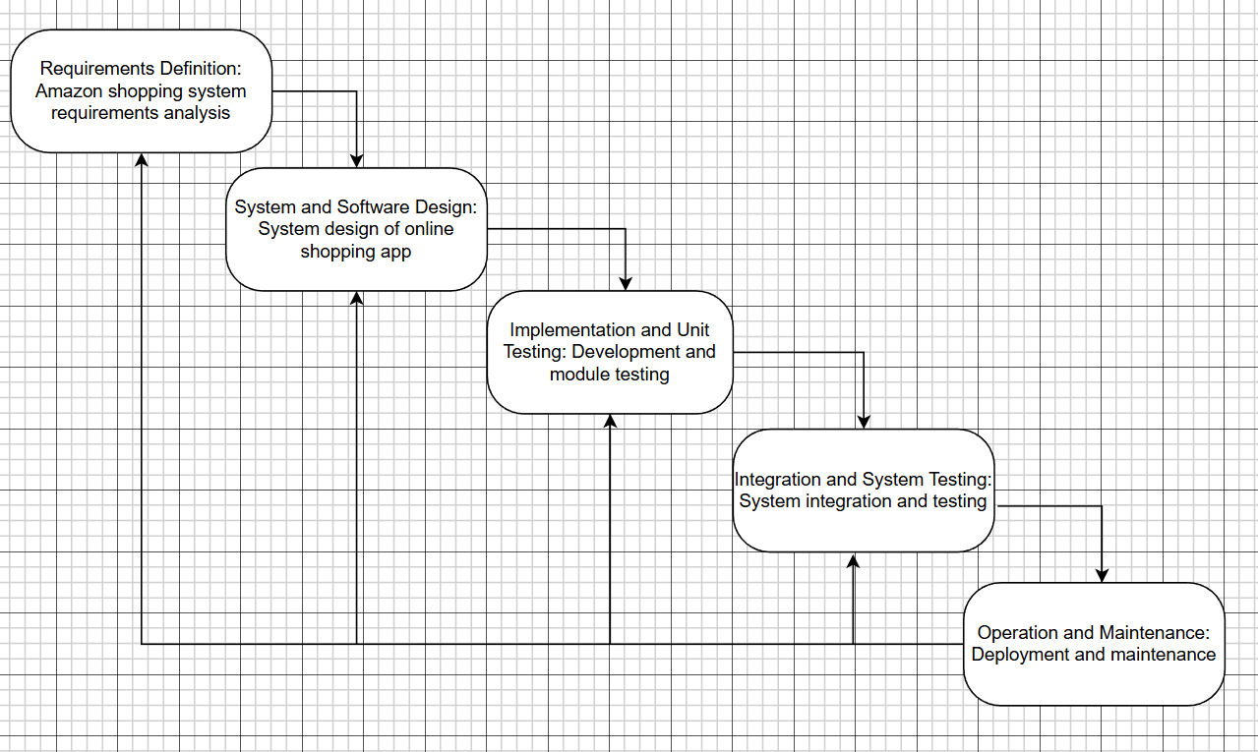

2. Incremental Model – Explanation for Amazon App
The Incremental model breaks down the system into small pieces where each increment goes through analysis, design, coding, and testing [1][2]. It is suitable for Amazon. Rather than building everything in one go, the app is broken down into modules. The initial part might involve user registration and browsing products. The subsequent part would involve the shopping cart and ordering products. Later parts would involve payment, tracking of deliveries, and customer reviews.

Each part is developed by following analysis, design, implementation, and testing. After each release, feedback is gathered, and enhancements are incorporated. This helps in dealing with changes in requirements [2]. For instance, if Amazon wishes to incorporate a new functionality such as “same-day delivery,” it can be incorporated in a later part without affecting the entire system.

This model enables early delivery of functional capabilities, improved user feedback, and step-by-step enhancement of non-functional requirements such as performance and usability. Therefore, it suits Amazon’s changing system.
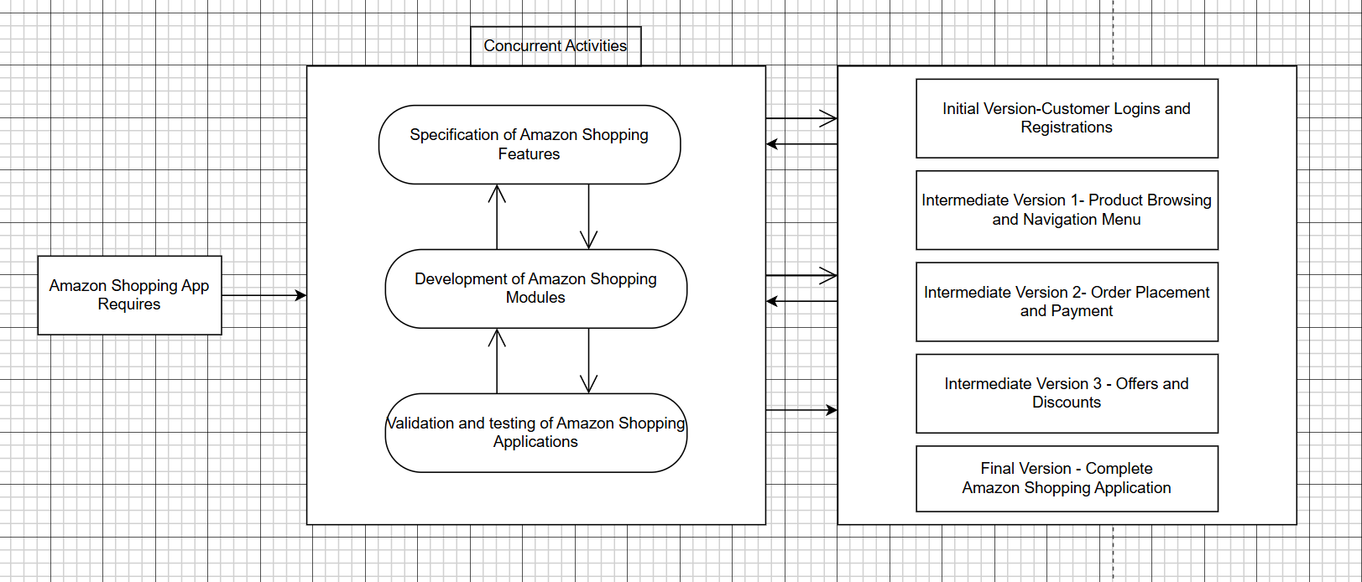

3. Spiral Model – Explanation for Amazon App
The Spiral model combines repetitive work and iterative deployment with thorough risk analysis [2][4]. Every cycle consists of four stages: planning, risk analysis, development, and review [4]. For Amazon, some risks might be security threats to payment, server overload during peak hours, data privacy issues, and integration issues.

During planning, objectives like implementing a new payment system are defined. During risk analysis, potential risks such as fraud or system failure are considered [4]. Next comes development and testing, followed by review with user feedback. The next cycle begins with better requirements.

As Amazon deals with confidential information and a huge amount of traffic, risk management is a critical aspect. The Spiral model identifies technical, monetary, and security risks early on and tackles them with utmost care. It might be time-consuming and expensive, but it is highly reliable and robust. Therefore, it is suitable for a complex system like Amazon.
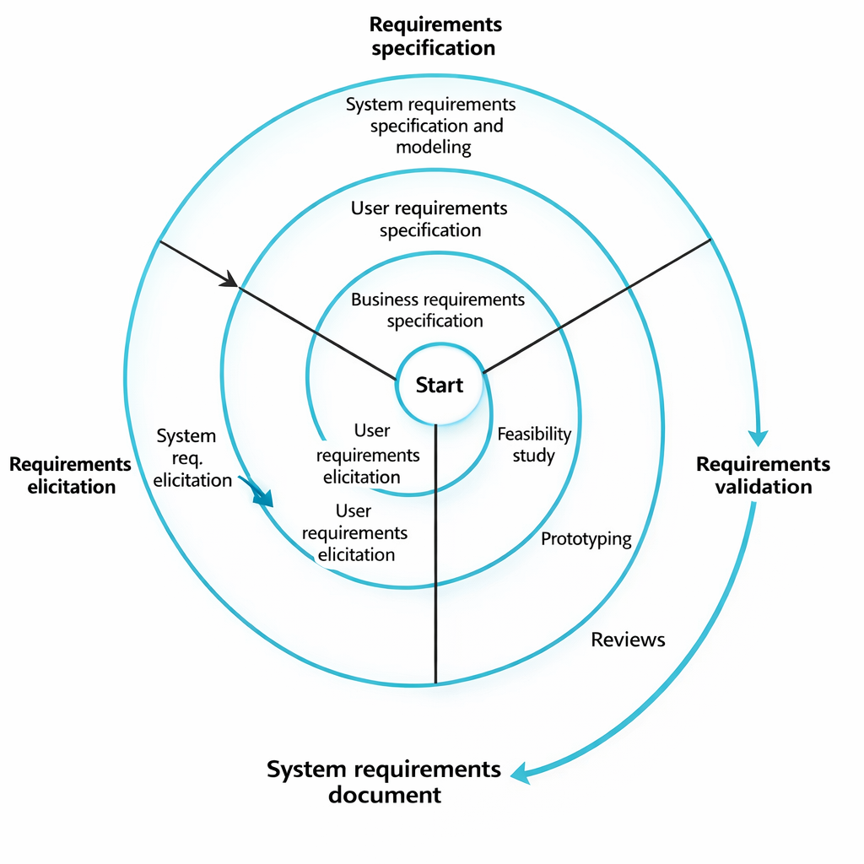

REQUIREMENT DOCUMENTS
Functional Requirements
Functional Requirements explains what the system must really do [3]. The Amazon shopping app should let users create accounts, log in, and manage their profiles, addresses, and payment details. Users must be able to search for products, browse categories, view product details, and see recommendations.
The system should allow users to add items to the cart, change quantities, and remove products. It must support a smooth checkout process where users choose delivery options and make payments securely. After ordering, users should track orders, see order history, cancel items (when allowed), and request returns or refunds. Notifications about orders, offers, and delivery updates should be sent.
Admins should manage products, prices, users, and reports. Sellers should upload products, update stock, and track sales.

Non-Functional Requirements
Non-Functional Requirements explains performance, security, and usability aspects [3].The app must be secure to protect user data and payment information. It should be fast and responsive, even during heavy traffic. The system must be reliable with very little downtime and should recover quickly from failures.
It should be scalable to handle millions of users at once. The app must be easy to use, available 24/7, and simple to maintain with regular updates and bug fixes.

Requirements Validation Strategy
The requirements are reviewed with stakeholders to ensure all key features are clear and complete. Simple prototypes may be used so users can confirm the system flow. Requirements are checked against business goals like security and performance.
Test cases are created to verify each requirement, and consistency checks are done to remove conflicts and ensure the system is feasible to build.

Challenges in Requirements Engineering
Requirement validation makes sure the system requirements are correct, complete, and consistent [3]. Requirements often change because the system keeps evolving. Understanding the needs of many different users can also be difficult, leading to misunderstandings. There may be conflicts between requirements, such as security versus performance. Managing requirements for such a large and complex system is itself a major challenge.

RESULTS AND ANALYSIS
The study shows that different SDLC models improves the development of the Amazon app in different ways. The Waterfall model provides a structured process but struggles when requirements change. The Incremental model allows early delivery of working features and better handling of updates. The Spiral model provides strong risk analysis and is highly effective in managing security and performance risks. Overall, iterative models perform better for dynamic e-commerce systems.

COMPARISONS
Handling Functional Requirements
The Waterfall model only works well when all the features are decided in the beginning. But for Amazon, that’s almost impossible because new features, offers, and services keep getting added. The Incremental model is more practical since features can be developed and added step by step. The Spiral model is even more flexible because in every cycle, requirements are reviewed and improved. This makes it very suitable for a system that keeps evolving like Amazon.

Handling Non-Functional Requirements
Things like security, speed, and scalability are very important for Amazon because millions of users use it at the same time. In the Waterfall model, these factors are planned early, but changing them later is hard. The Incremental model improves these qualities gradually with each release. The Spiral model handles them best because it keeps checking system performance and risks in every cycle, which helps in building a more stable and reliable system.

Risk Management
The Waterfall model doesn’t really focus much on risks during development. If something goes wrong, it is usually found very late. The Incremental model reduces risk by testing each part of the system before moving forward. The Spiral model is the strongest in handling risks because risk analysis is a main step in every cycle. This is very important for Amazon since even small system failures can cause huge losses.

Change Management
In the Waterfall model, once a phase is completed, going back and making changes is very difficult and costly. The Incremental model is better because changes can be made between increments. The Spiral model is the most flexible since each cycle allows reviewing and updating requirements, which is useful for an app like Amazon that constantly changes.

Time Constraints
The Waterfall model takes more time because the final product is delivered only after all stages are finished. The Incremental model is faster in showing results since working versions are released early. The Spiral model can take longer because of repeated testing and analysis, but this extra time helps in building a better-quality system.

Cost Constraints
At first, the Waterfall model may look cheaper, but if changes are needed later, the cost increases a lot. The Incremental model spreads the cost over different stages. The Spiral model is usually more expensive because of continuous risk analysis and iterations, but it reduces the chances of failure, which saves money in the long run.

USER FEEDBACK
In the Waterfall model, users normally get to see the system only at the end, so feedback is received very late. In the Incremental model, users can provide feedback after each release. In the Spiral model, users are brought in periodically, which is very helpful in continuously improving the system.

APPLICABILITY TO AMAZON APPLICATION
For Amazon, the Waterfall model is not very appropriate since it is not able to cope with changes. The Incremental model is very appropriate since it allows the development of features incrementally. However, the Spiral model is the most appropriate since it deals with risks, copes with frequent changes, and maintains the system’s reliability.
LIMITATIONS AND FUTURE WORK
This project is more about analysing different models of SDLC and developing system requirements rather than developing the actual Amazon app. There was no actual coding, testing, or use of actual user data. We had to assume some things about how the system would function, which might not be the same in the real world.
In the future, it could be improved by assembling a functional prototype and testing it on actual users. We could explore more into the functionality of smart recommendations, enhanced security, and quick search.
The research could be further expanded by comparing different development methodologies and using more effective tools for dealing with requirements and testing.

CONCLUSION
This particular project examined the SDLC of the Amazon Online Shopping App by comparing the Waterfall, Incremental, and Spiral models. We created a simple requirements doc and discussed how requirements validation is done. The results indicated how each model addresses functional and non-functional requirements, risks, changes, time, and cost.
The key point here is that selecting the appropriate development model is very important for the success of a project. Waterfall is not very flexible, Incremental development allows you to develop in stages, and Spiral development provides excellent risk management and opportunities for continuous improvement.
In conclusion, the Incremental and Spiral models are more appropriate for large-scale e-commerce applications such as Amazon because they provide greater flexibility, reliability, and requirements management.

REFERENCES
[1] Ian. Sommerville, Software Engineering, 10th ed., Pearson, 2016.
[2] R. S. Pressman and B. R. Maxim, Software Engineering: A Practitioner’s Approach, 8th ed., McGraw-Hill Education, 2015.
[3] K. E. Wiegers and J. Beatty, Software Requirements, 3rd ed., Microsoft Press, 2013.
[4] B. Boehm, “A Spiral Model of Software Development and Enhancement,” Computer, IEEE

Declaration of Academic Integrity
I hereby declare that this assignment is my original work and has not been copied or plagiarized from any source. All references and resources used have been properly cited. Any ambiguities will lead to forfeiting my marks.


Signature:

Date :13-02-2026

